**MySQL – DML Command demonstrate**

Download dataset for executing the SQL commands for the exercises.

<https://raw.githubusercontent.com/sitmbadept/sitmbadept.github.io/main/BDTM/SQL/bdtm.sql>

Step - 1 : Copy entire codes from bdtm.sql file/above link and paste in SQL command windows.

Step - 2: Click on Go button

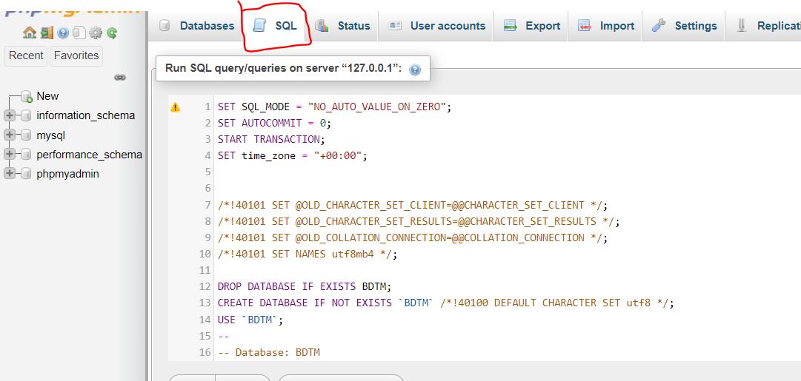

Step -3 : After execution, refresh the web page(phpmyadmin)

Step -4 : new bdtm database will appear in left panel window.

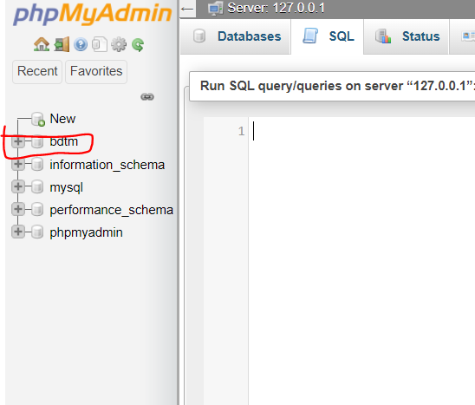

Before executing any SQL commands first step is to select **bdtm** database for following questions. Click on bdtm database on left panel to select it.

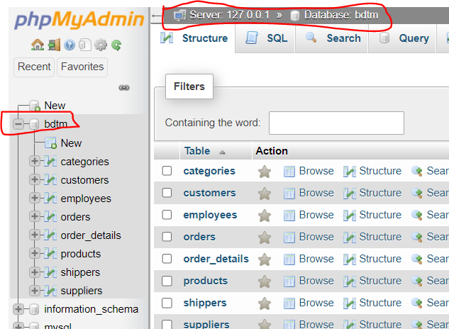

Write SQL statements for following questions:

1. List all the tables available in bdtm database.
2. Display all the records available in customers table.
3. Display CustomerName and Country from customers table
4. Display CustomerID, CotactName, City, County from customers table
5. Sort Customer data in ascending order based on Country name(A-Z)
6. Sort Customer data based in descending order based on ContactName (Z-A)
7. Filter out USA customers with all the columns from customers table
8. Display all the columns from order_details table
9. Get the total order Quantity in order_details table
10. Summaries total Quantity per OrderID in order_details table
11. Display OrderID which has Quantity greater than 180
12. Display OrderID which has Quantity less than 5
13. Display all the categories details available in Categories table
14. Check total number of records present in suppliers
15. Display minimum product price from products table.
16. Display maximum product price from products table.
17. Filter out the products where price between 80 to 300
18. Filter out the customers from USA, Brazil and Canada

**SQL Codes**

1. List all the tables available in bdtm database.

**SHOW TABLES;**

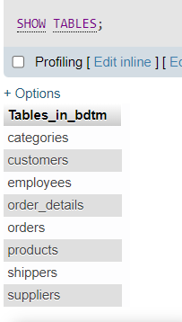

1. Display all the records available in customers table.

**SELECT * FROM customers;**

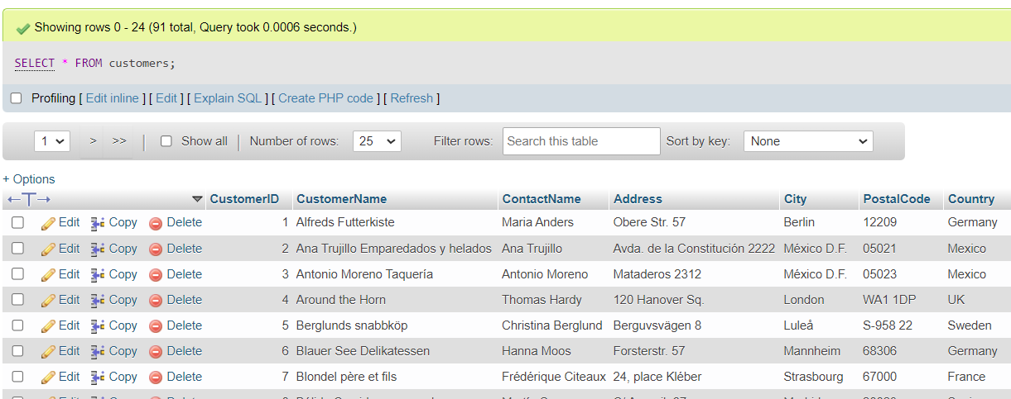

1. Display CustomerName and Country from customers table

**SELECT CustomerName, Country FROM customers;**

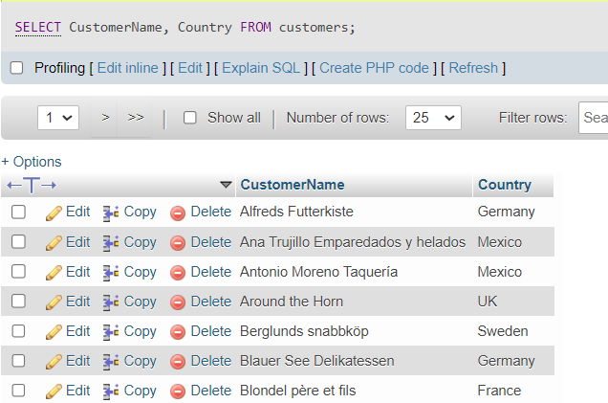

1. Display CustomerID, CotactName, City, County from customers table

**SELECT CustomerID, ContactName, City, Country FROM customers;**

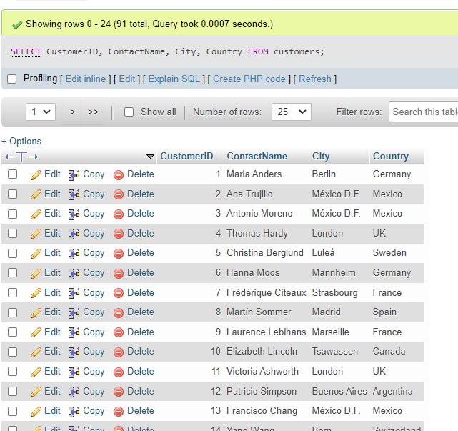

1. Sort Customers data in ascending order based on Country name(A-Z)

**SELECT * FROM customers ORDER BY Country ASC;**

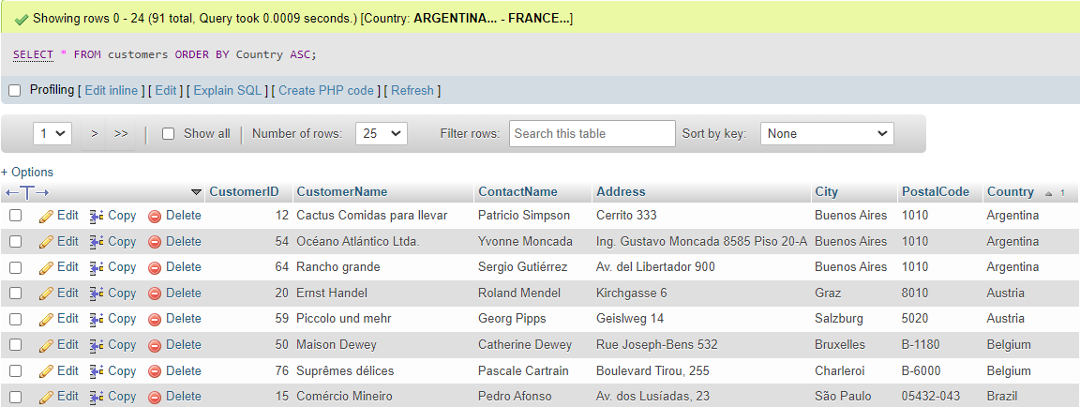

1. Sort Customersss data based in descending order based on ContactName (Z-A)

**SELECT * FROM `customers` ORDER BY ContactName DESC;**

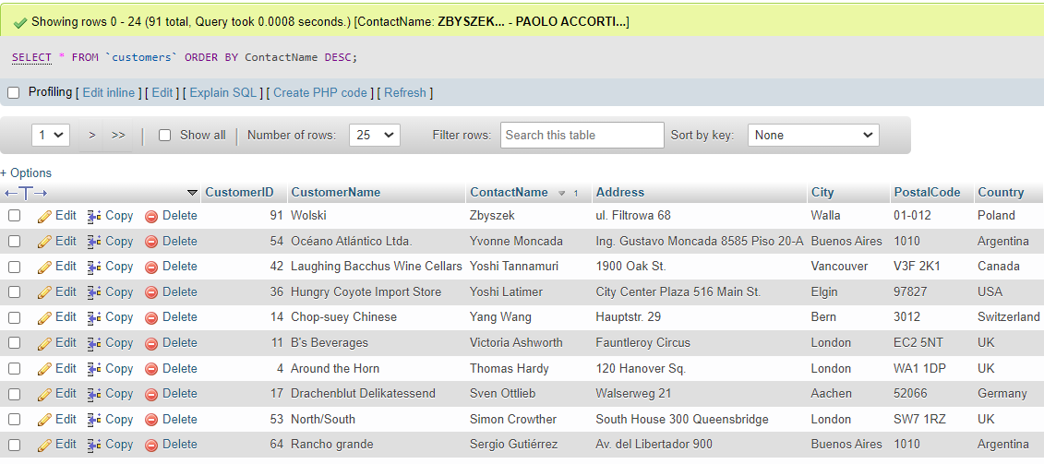

1. Filter out USA customers with all the columns from customers table

**SELECT * FROM customers WHERE Country = 'USA';**

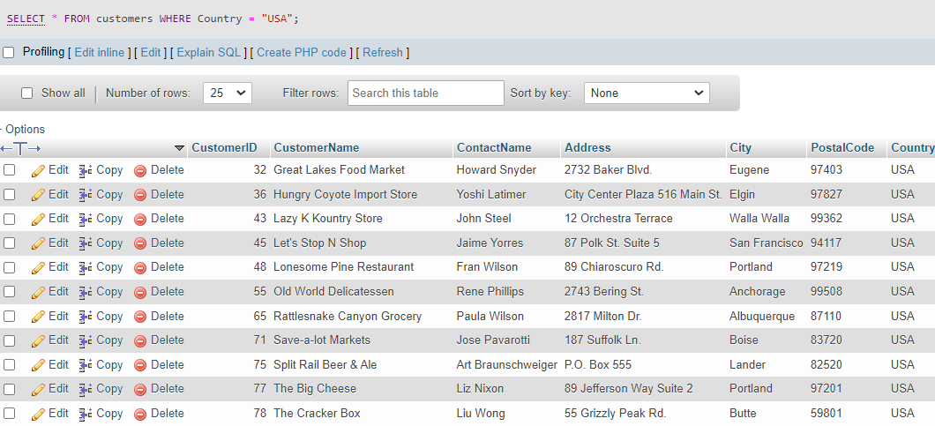

1. Display all the columns from order_details table

**SELECT * FROM order_details;**

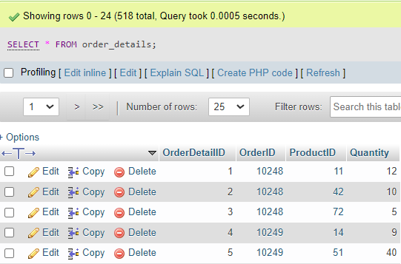

1. Get the total order Quantity in order_details table

**SELECT SUM(Quantity) FROM order_details;**

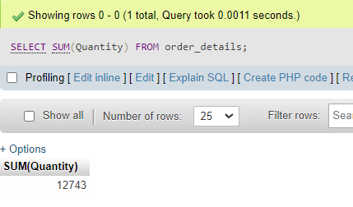

1. Summaries total Quantity per OrderID in order_details table

**SELECT OrderID, SUM(Quantity) FROM order_details GROUP BY OrderID;**

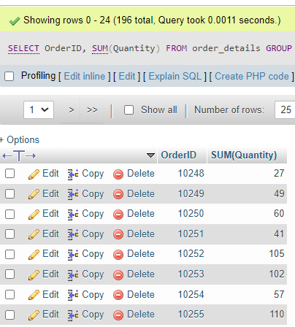

1. Display OrderID which has Quantity greater than 180

**SELECT OrderID, SUM(Quantity)**

**FROM order_details**

**GROUP BY OrderID**

**HAVING SUM(Quantity) > 180;**

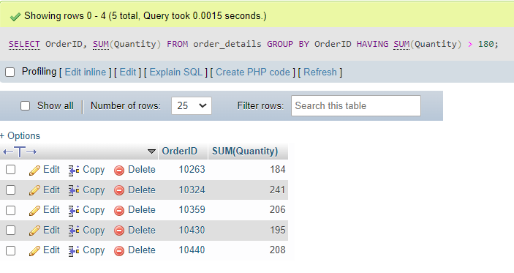

1. Display OrderID which has Quantity less than 5

**SELECT OrderID, SUM(Quantity)**

**FROM order_details**

**GROUP BY OrderID**

**HAVING SUM(Quantity) < 5;**

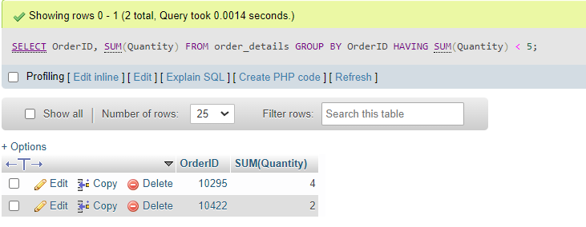

1. Display all the categories details available in Categories table

**SELECT * FROM categories;**

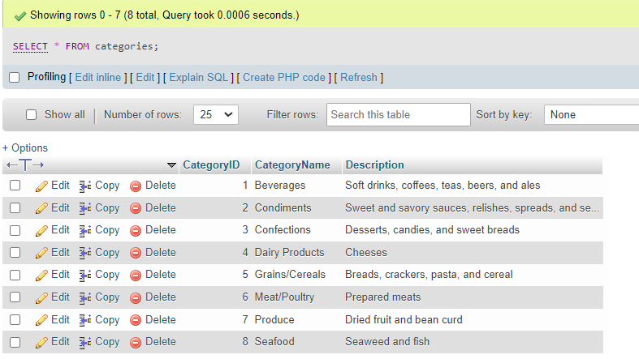

1. Check total number of records present in suppliers

**SELECT COUNT(*) FROM suppliers;**

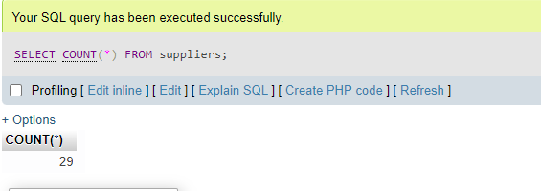

1. Display minimum product price from products table.

**SELECT min(Price) FROM products;**

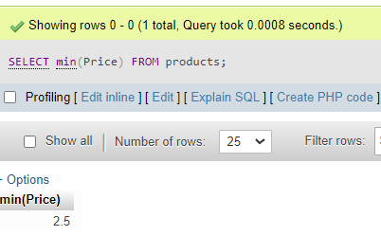

1. Display maximum product price from products table.

**SELECT max(Price) FROM products;**

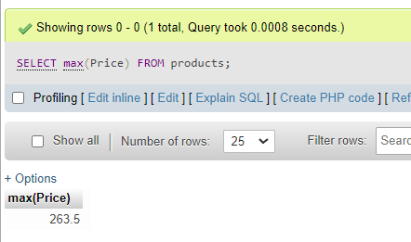

1. Filter out the products where price between 80 to 300

**SELECT * FROM products WHERE Price BETWEEN 80 AND 300;**

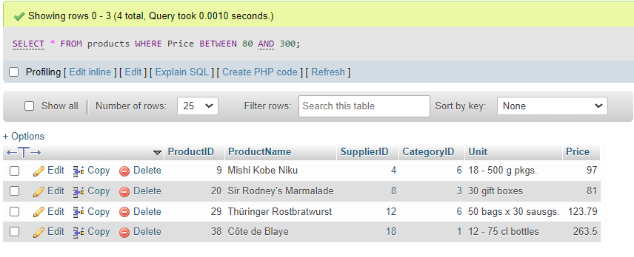

1. Filter out the customers from USA, Brazil and Canada

**SELECT * FROM customers WHERE Country IN ('USA', 'Brazil', 'Canada');**

